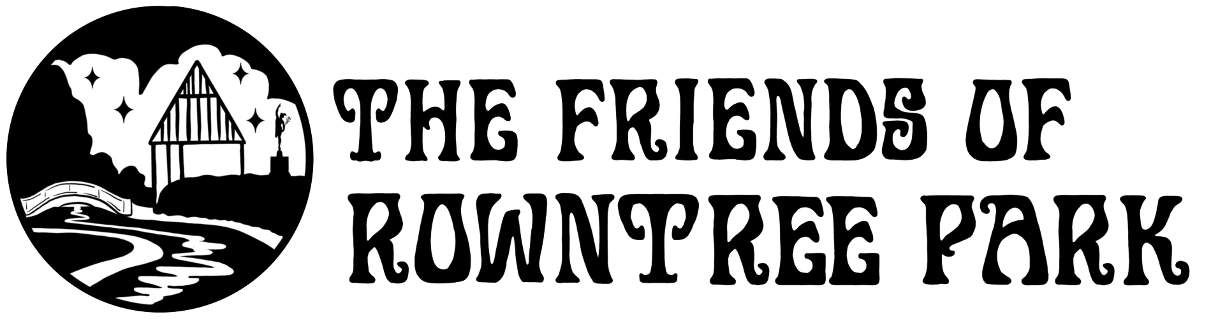

Fundraising Volunteer Role Description

About the role | Friends of Rowntree Park is a small charity with big ambitions! As public funding for parks and open spaces becomes increasingly stretched, we have to raise our own money for projects to enhance the park. That’s where our fundraising volunteers come in! We generate money through events, membership fees, applying for grants, and other fundraising activities, and we need volunteers to help with all aspects of our fundraising.
When do we need volunteers? | We need fundraising volunteers throughout the year, usually at weekends. As well as regular volunteers, we’d like to build up a list of people who we can call on when we need extra help with fundraising activities. If you’re interested in running a fundraiser, we’ll work with you to plan the best time for it.
Who are we looking for? | If you have experience of fundraising or applying for grant funding, we’d be delighted to hear from you. If you don’t have experience but you have a great idea and lots of enthusiasm, get in touch!
What is the commitment? | It really depends how much you want to take on! Running a fundraiser can be a big job, but you could choose to take more of a supporting role and only volunteer occasionally.
What will I get from the role? | If you’re not an outdoorsy type, but still want to make a difference to the park, this could be a great role for you. You’ll get to use your creativity, work with a great team, and be part of the excitement of running fundraising activities! This is a role where the impact of what you’re doing is easily quantifiable which is very satisfying, but more importantly, volunteering is great for your wellbeing and sense of community.
What training do I need? | All volunteers need to attend a short induction session before they start their role. Once you have completed the session, you will be covered by City of York Council insurance while volunteering.
References and DBS | We do not ask for references or a DBS check for this role.
How do I sign up? | To get involved, please fill in our volunteer registration form. If you’ve got any questions, email volunteer@rowntreepark.org.uk.

