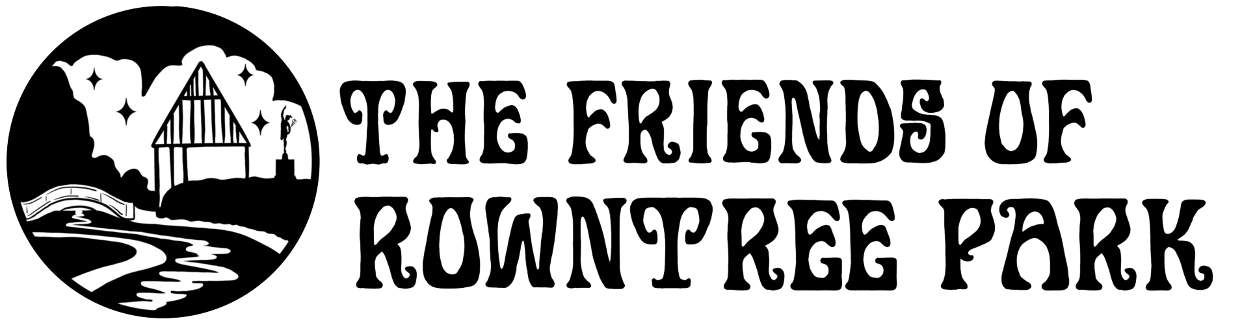

Volunteer Role Description - Gardening

About the role | Our team of volunteer gardeners do a fabulous job of making sure that Rowntree Park looks its best. The council manage the park but in recent years budget cuts mean there are no staff based in the park and no new planting. A travelling team of maintenance workers will cut grass and hedges and clear overgrowth but any new design and planting is funded and done by the Friends of Rowntree Park volunteers.  Our volunteers create and care for the following areas - the long borders, the sensory garden, the family picnic garden, the pollinator project, the new wildlife area, the rose pergola and footprint maze memorial area, and we also have a small closed garden for potting and growing some plants.It’s a big job, so we’re always looking for new people to get involved. You can choose areas you are interested in or try a bit of all. We have a mix of tasks available for all abilities and a range of ages.
When do we need volunteers? | We have regular weekday morning sessions and we welcome people to choose a day to attend - volunteering is to fit around you life so come once, come more - you are very welcome! We also occasionally host weekend sessions. Volunteers can come in their own time too once basic training is given.  Currently we run sessions at the following times:  Mondays 9.30-11.30 - Pollinator Project  Tuesdays 9.30-11.30 - Sensory garden (Feb-Nov only)  Thursdays - Long Borders/Friends garden  Fridays 9.30-11.30 - Rose Garden  We also have alternative wednesdays Spring and summer 2022 working in the new Tansy Beetle Habitat area. We are planning ‘one off events’ in the wildlife area too (probably weekends).  Once inducted (trained) you are also welcome to garden in the park in your own time.
Who are we looking for? | Anyone who is keen can be a volunteer gardener. Full training will be given, so you don’t need any gardening experience.  Suitable for all ages 18 and over. We have a nice mix of ages, backgrounds and interests. We have a small area for propagating plants, and this can be a good activity for anyone with restricted mobility who would like to get involved. Al;so the rose garden work includes ‘light touch’ pruning.
What is the commitment? | You can come to sessions as often as you like. There’s no obligation to come every week. Upou can come for a one off, a set of sessions or attend for a longer period.
What will I get from the role? | Our gardening sessions are friendly and sociable. If you’re a novice gardener, you’ll pick up lots of tips that you can use in your own garden. Volunteering outside is known to be particularly good for your wellbeing, both physical and mental.
What training do I need? | All volunteers need to attend a short induction session before they start their role. Once you have completed the session, you will be covered by City of York Council insurance while volunteering as well as our own.
References and DBS | We do not ask for references or a DBS check for this role.
How do I sign up? | To get involved, please fill in our volunteer registration form. If you’ve got any questions, email volunteer@rowntreepark.org.uk.

