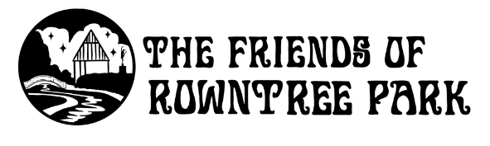

Marketing & Advertising Volunteer Role Description

About the role | The Friends of Rowntree Park are a group of passionate and dedicated volunteers who help to manage the park’s green spaces through their gardening, conservation and projects. They also run a range of nature based events and activities.  We seek a person, or people, to help with our marketing and advertising of some, or all of the following (dependent on volunteer interests):  -Volunteering  -Membership  -Events  The Friends of Rowntree Park have a good following on a range of social media platforms, and we’d be looking to utilise these in addition to sharing opportunities mentioned above. In addition the use of posters and flyers and sharing information with other organisations/groups (including events listings).  Marketing and Advertising volunteers could do one, or some of the following - subject to discussion based on interest and skills:  - Strategy for increasing membership/volunteering  - Creating resources for advertising and marketing membership/volunteering/events  - Run membership awareness stalls/events  - Run volunteer awareness stalls/events  - Creating social media content linked to any of the above areas or working in conjunction with social media content creation volunteers.
When do we need volunteers? | This is a really flexible role that volunteers can do from home.
Who are we looking for? | We are looking for volunteers with some experience of using social media and producing marketing materials. You don’t need to have professional marketing experience, but some knowledge of how to produce promotional material and use social media effectively is key for this role. Most of all, you’ll need to be enthusiastic about the park and our events, and able to share that with others!  Skills required  - Enthusiasm  - Good communication skills  - The ability to work in a team with people of different ages and backgrounds - communicate clearly and be well organised.  - Desire to help in the community  Applicants must be 18 years of age and above.
What is the commitment? | Ideally, we are looking for a small number of volunteers who can help out regularly. It’s a “little and often” job.
What will I get from the role? | If marketing and social media are relevant to your career, this is a great way to build up extra experience (and boost your CV). If you’re not especially outdoorsy, this is a great way of helping Friends of Rowntree Park from the comfort of your home.  What you’d gain:  - Experience of working outside on a community project  - Strengthen your ability to work as part of a team - liaising  - Skills on monitoring and evaluating impact of strategies tried  - Meet members of this passionate community group  - The chance to make a real difference to a much loved community space; ultimately bringing more attention to its existence and the wonderful work of the volunteers there.
What training do I need? | You’d check in with the charity manager to discuss/bounce ideas. There would be a basic induction to find out more about the charity and elements of what we do, and then expected to read and agree to the volunteer code of conduct.
References and DBS | We do not ask for references or a DBS check for this role.
How do I sign up? | To get involved, please fill in our volunteer registration form. If you’ve got any questions, email volunteer@rowntreepark.org.uk.

